Uploading Files to Dropbox:

Step 1: Navigate to dropbox
www.dropbox.com
Step 2: If you have an account, click on sign in or you can sign-up.
Step 3: Once you logged in, you will be having a similar page like following:
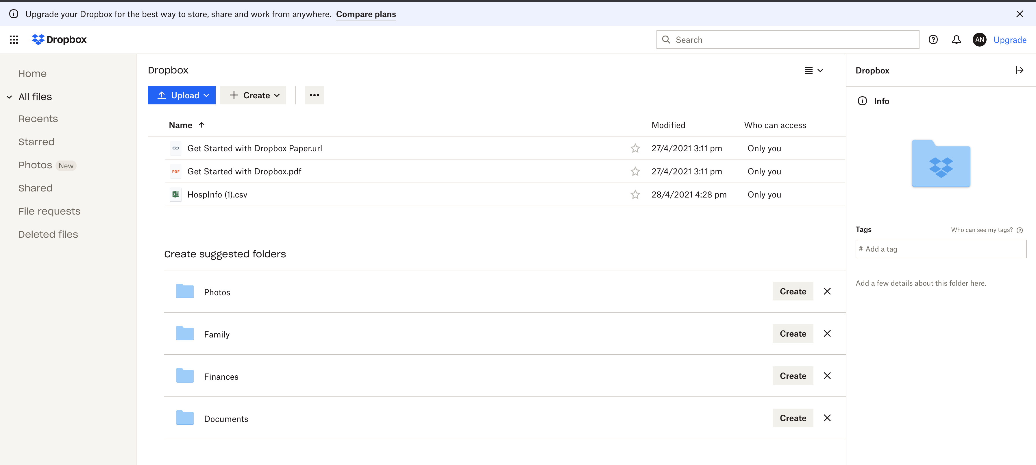
Step 4: Click on Upload, and upload the files from the local PC.

Connecting Dbeaver:
Step 1: You can download dbeaver from the following link:
https://dbeaver.io/download/

Step 2: Download community edition.
Step 3: Instal Dbeaver in the PC and open the Dbeaver
Step 4: Click on 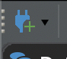 (Add new connection) icon, to add a connection to the SQL.
Step 5:You will get a following screen, once you click on the add new connection icon, select the required database from it.
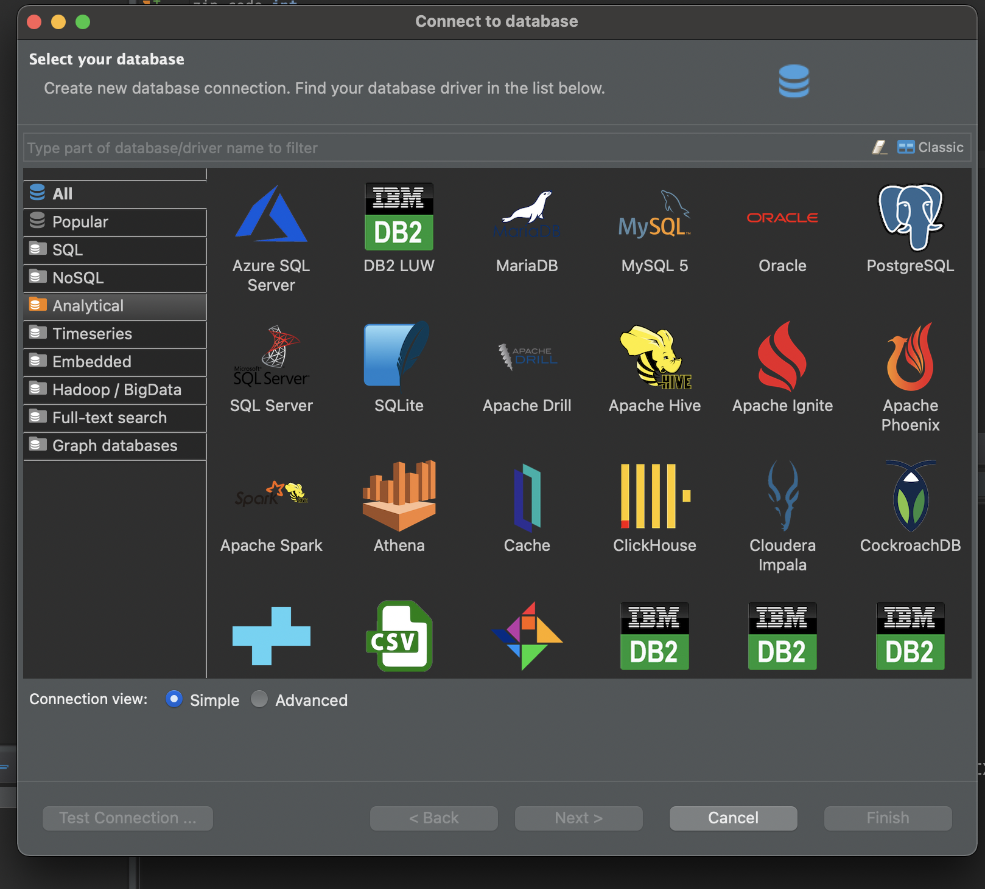
Step 6: Provide host details, dbname, username and password and hit test connection. If the connection is success, hit on finish.
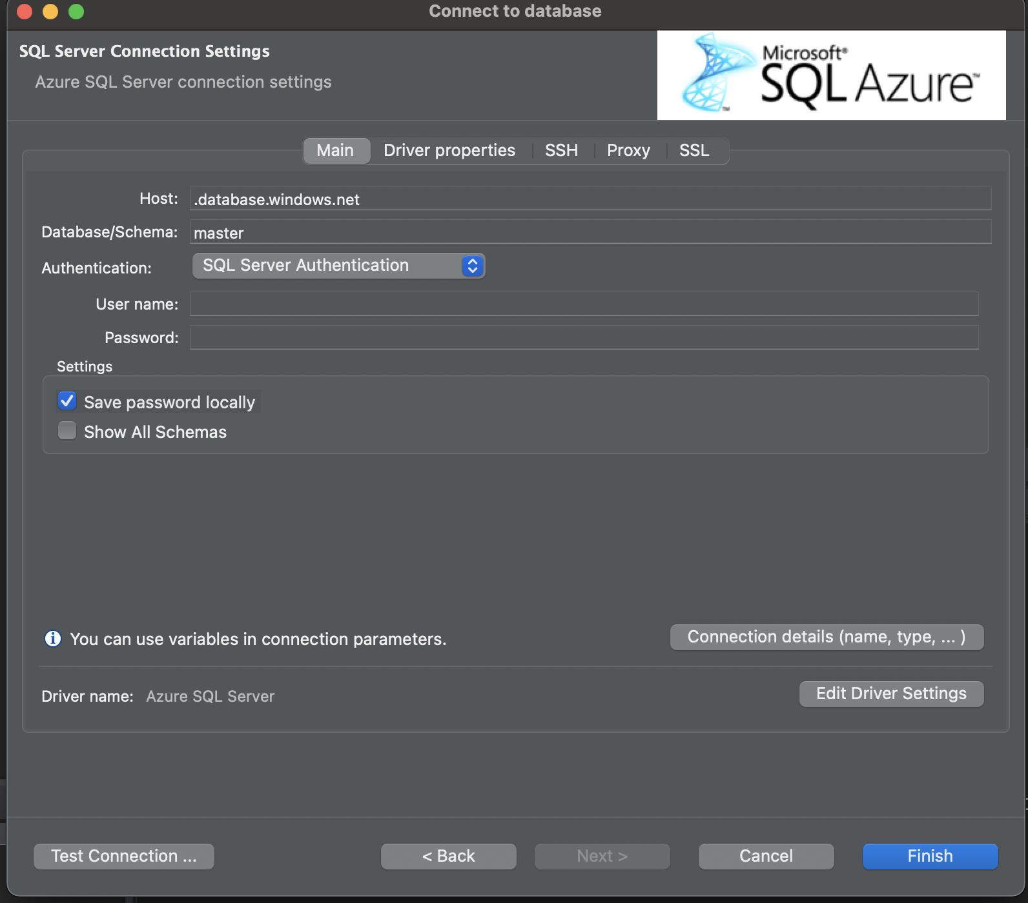
Step 7: The connection with the DB has been established, right click on the db and click on new SQL editor to write queries.

